***Submitted By: Ankit Priyadarshi*** ([ankit.priyadarshi2020@vitbhopal.ac.in](mailto:ankit.priyadarshi2020@vitbhopal.ac.in)) ***– 20BCE10486***

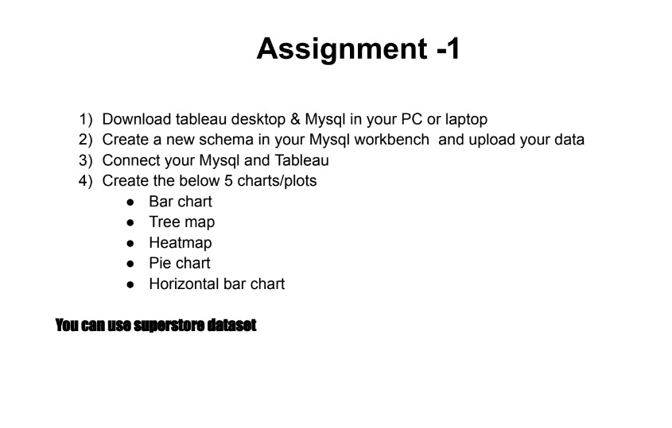

1. 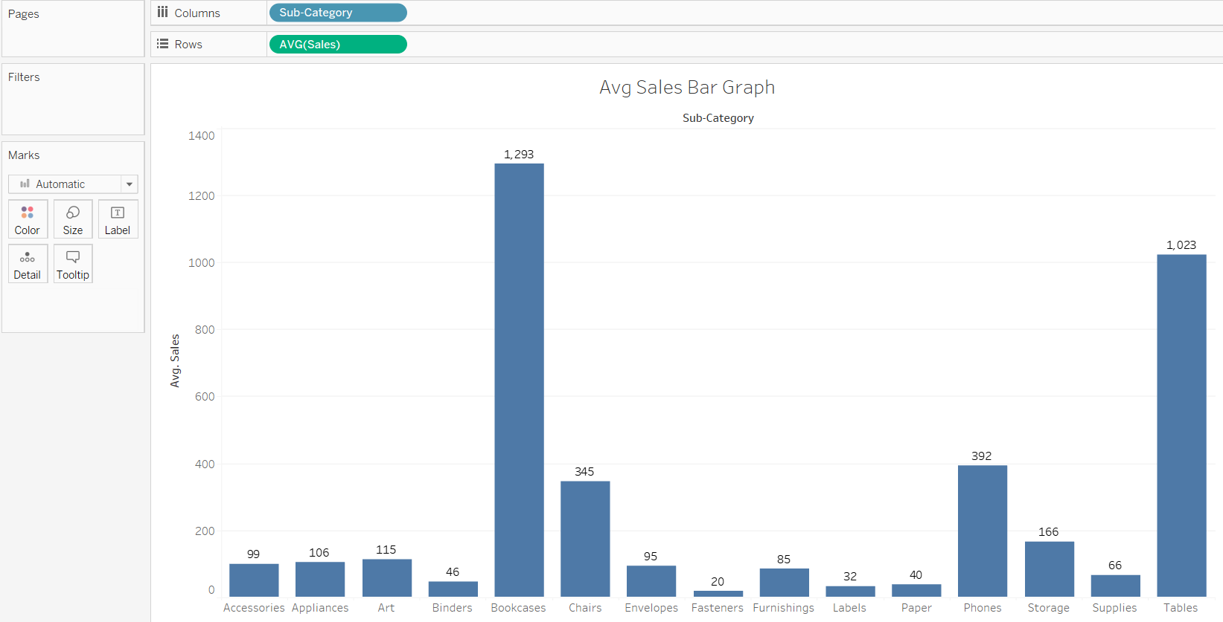**Bar Chart**
2. 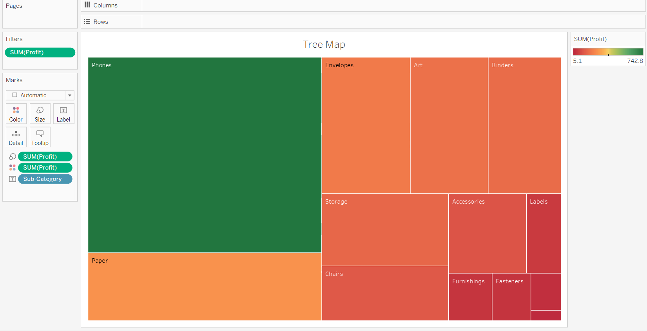**Tree Map**
3. 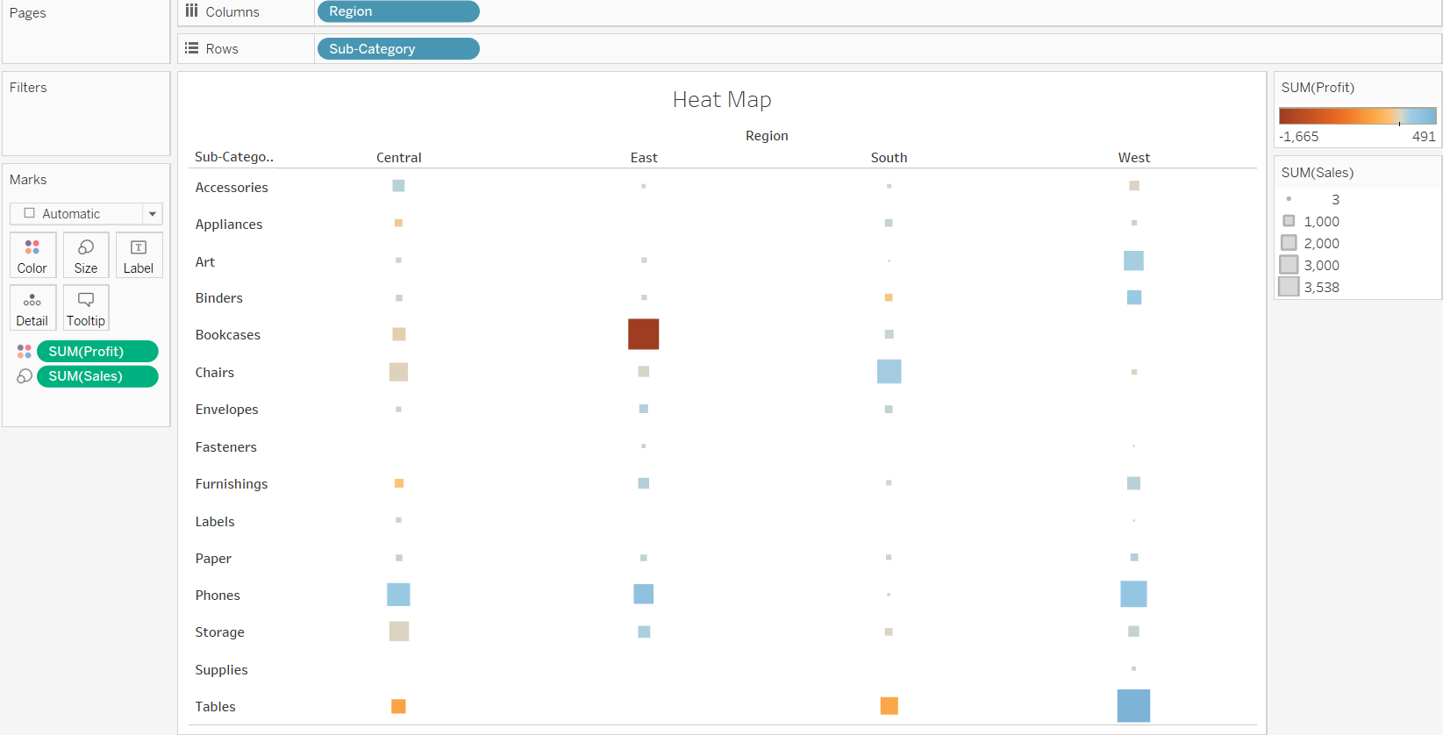**Heat Map**
4. 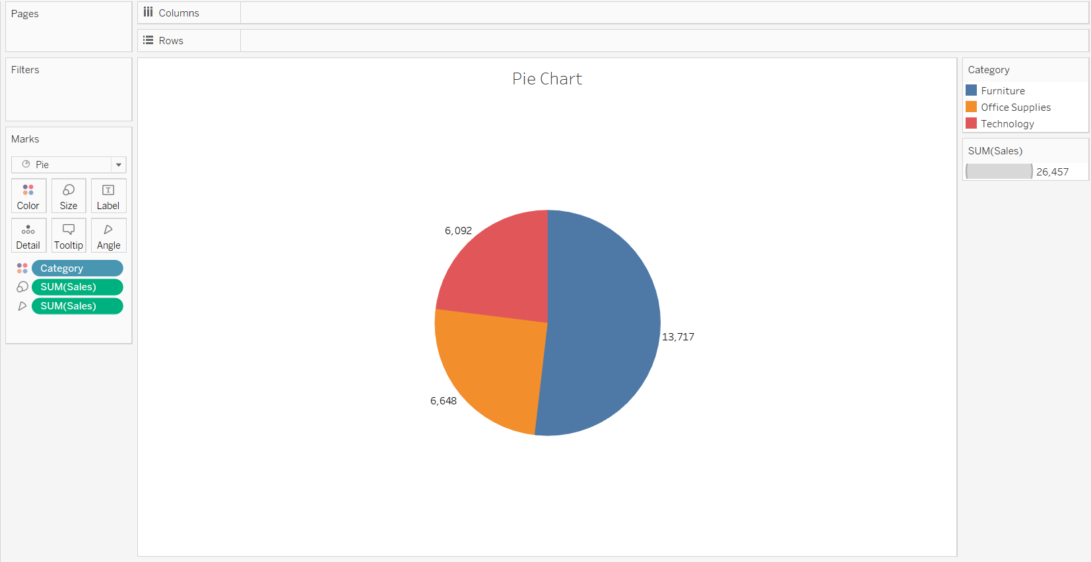**Pie Chart**
5. 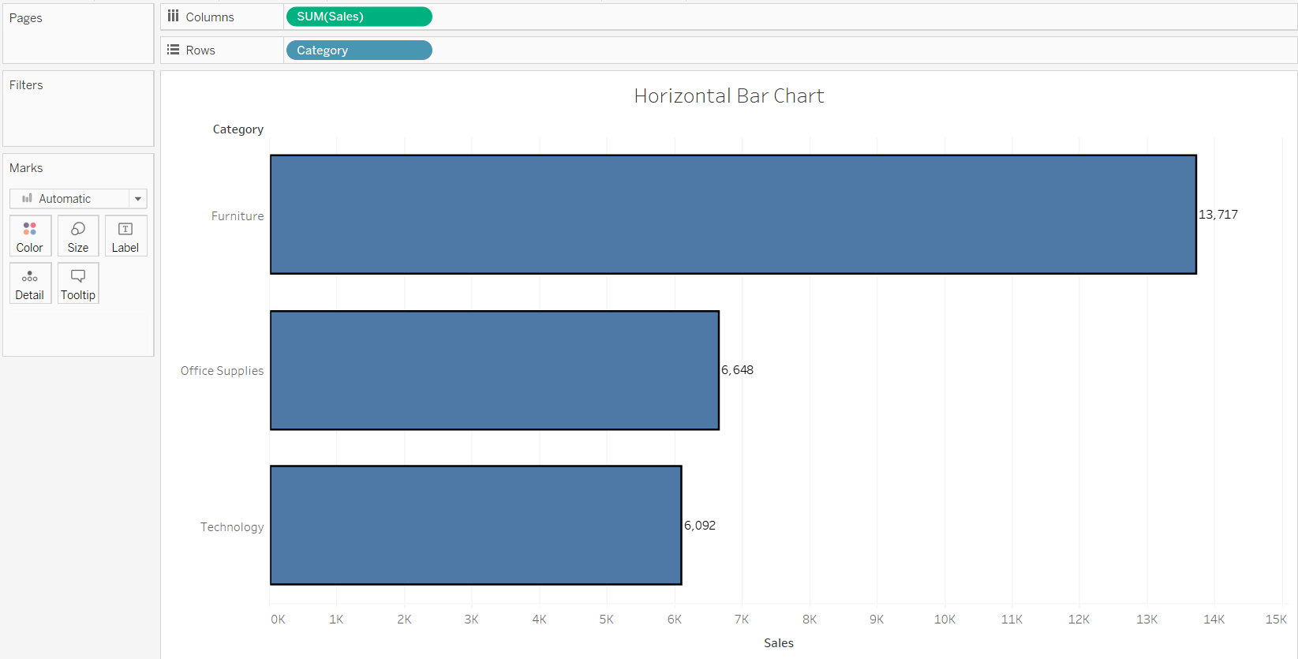**Horizontal Bar Chart**